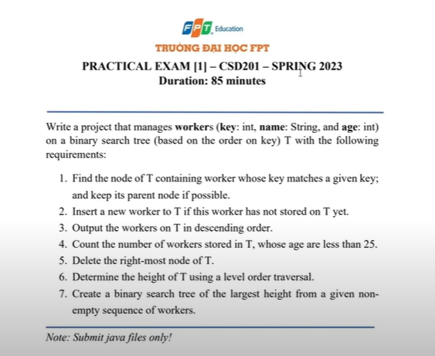

‘Write a project that manages workers (key: int, name: String, and age: int)

On a binary search tee (based on the order on Key) T with the following requirements:

1. Find the node of T containing worker whose key matches given key; and keep its parent node if possible.

2. Insert a new worker to T if this worker has not stored on T yet

3. Output the workers on T in descending order.

4. Count the number of workers stored in T, whose age are less than 25.

5. Delete the right- most node of T.

6. Determine the height of T using a level order traversal.

7. Create a binary search tree of the largest height from a given non-empty sequence of workers.